When I went to save to research. Again don’t know what any of this means. It’s too much information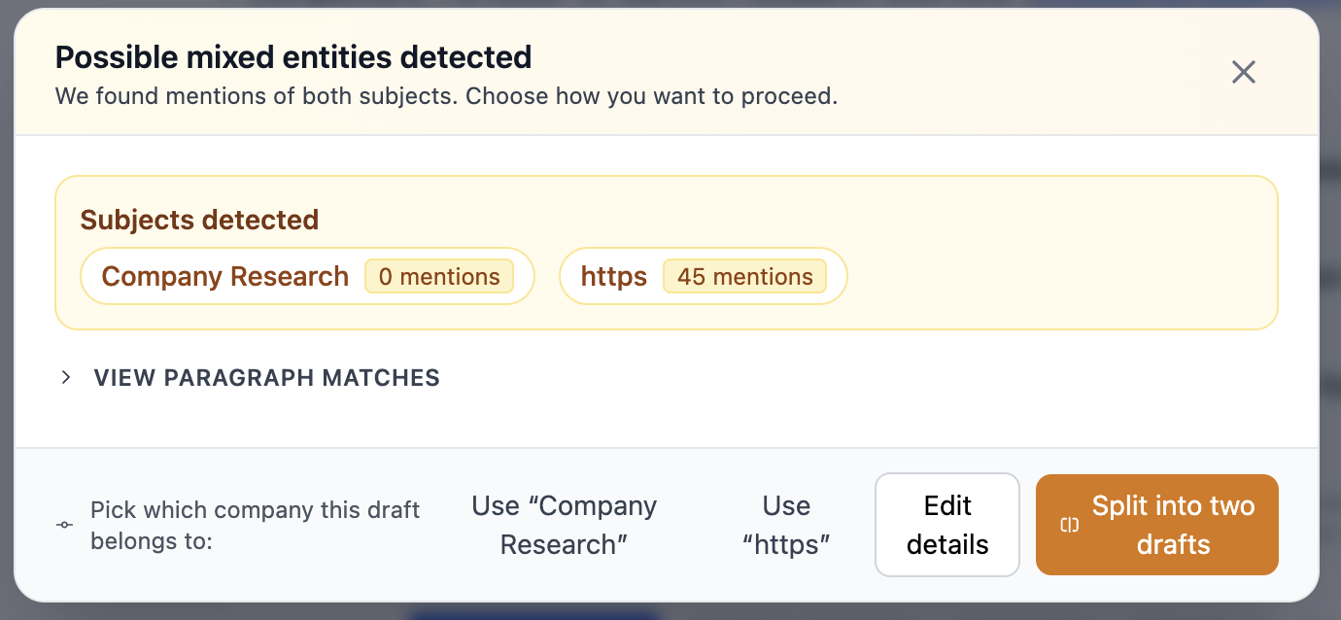

If I click on say on continue this company then click start new company something should move. The highlight is stuck on start new company so you don’t know what is selected. It’s a confusing UX. And nothing happens if I click start new company, email draft, or continue this company. If I click summarize it acts as I would expect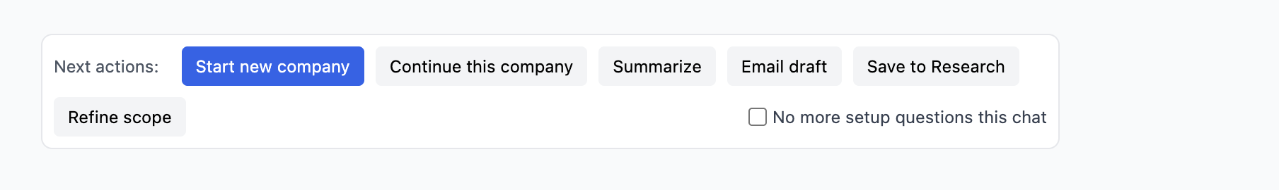When I click on refine scope all 6 of those should be checked (or whatever was set upon setup). It needs to reflect the current state when you click on it and ideally then you can uncheck or check as needed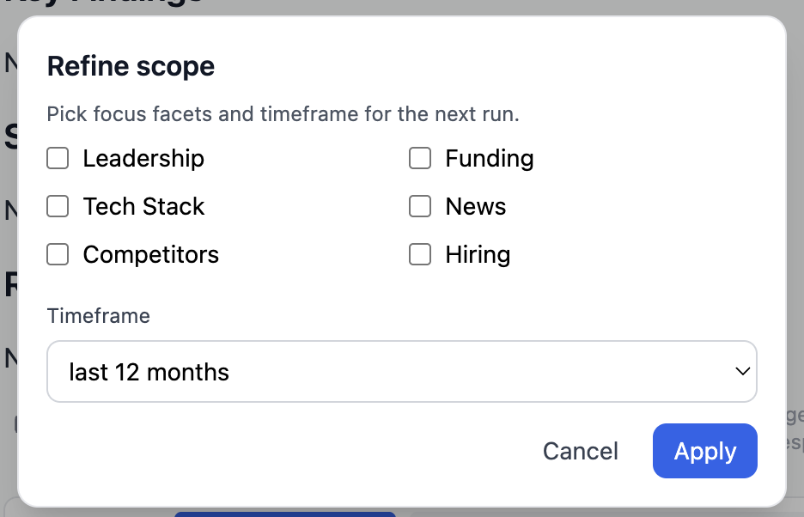

So this is really cool and has a lot of potential. Suggesting things like this and it actually working. Can we make the next steps either clickable or executable somehow. Like if it suggests to do 4 things you can select which ones you want it to help you with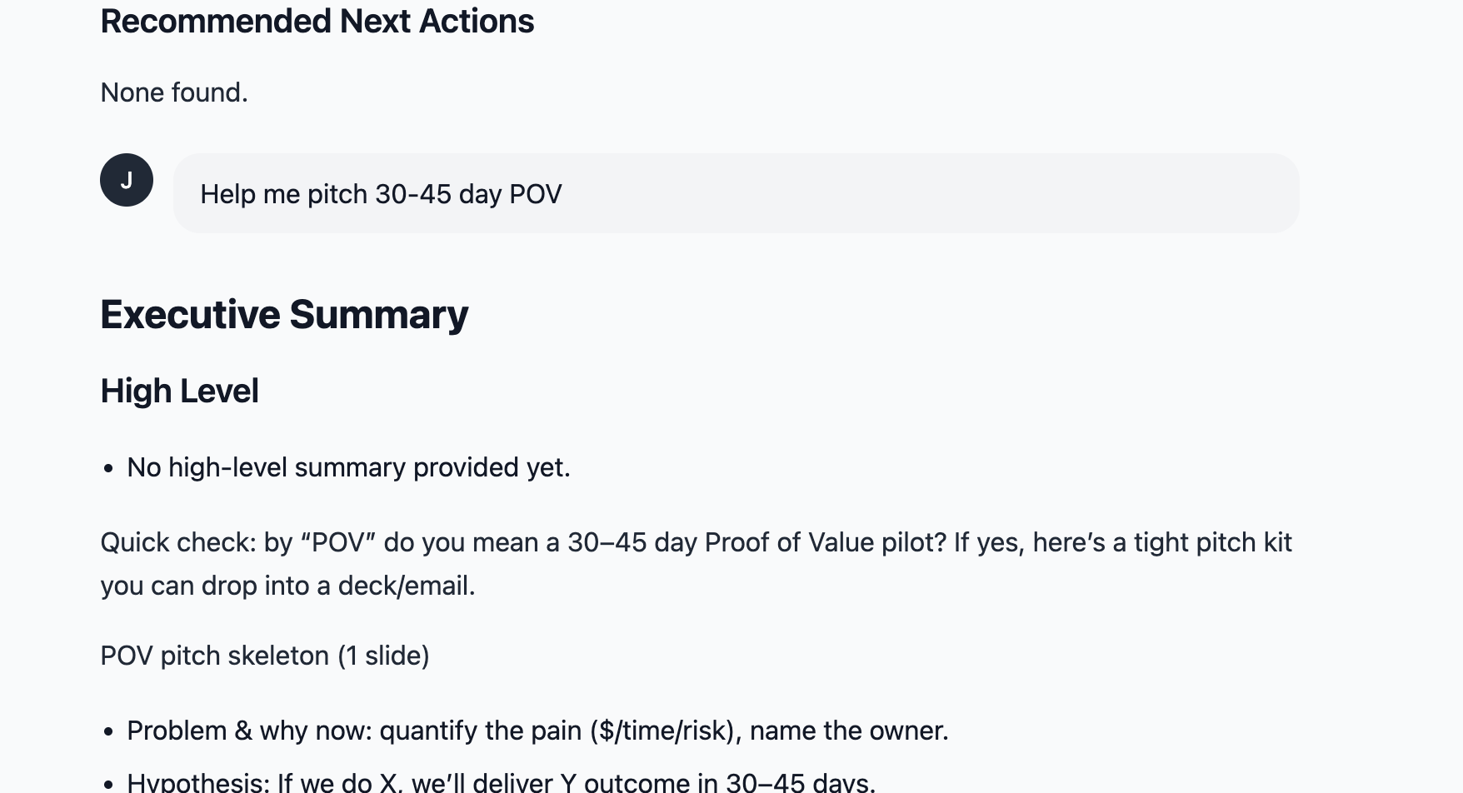This message doesn’t make sense.I just searched for [clair.com](http://clair.com) after searching for keepit and it still shows in the expectations box the original company researched.

Again. It’s not taking context from the research before. I searched clari. Then after it gave me the results I asked a follow up question about their CEO . It shouldn’t have to ask me who I am referring to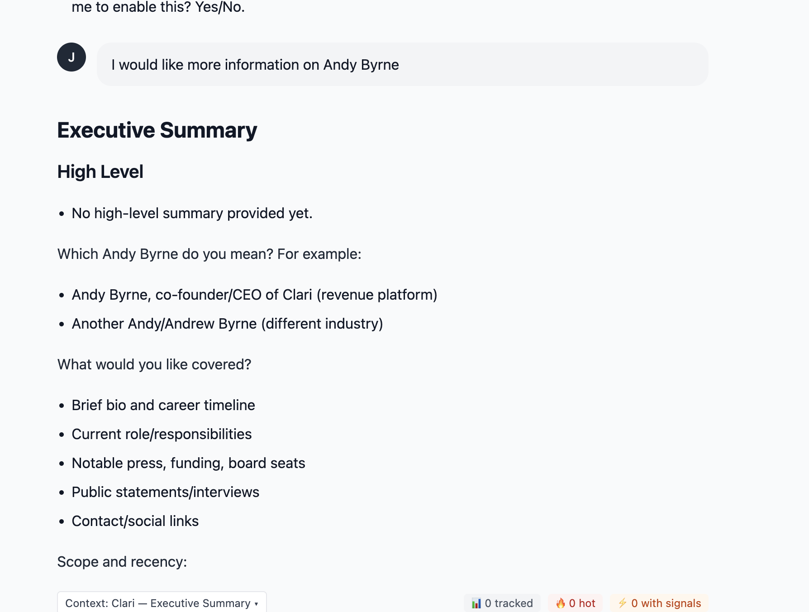

The welcome agent first options should be listed first as take 5 minutes to setup your research agent (help me help you). Or dive into research now and set it up as you go (I can automate and learn as I go)

The welcome agent says there are checkboxes but I don’t see any

After I go through the setup process and I go to research a company it does two things. First it asks me if it has the correct company and provides a few details. When I say yes it asks me then to add the domain name which doesn’t make sense since it has already identified the company.

Second it asks me what I would like researched. Which doesn’t make sense since I have already gone through the setup process

Why would I need to do this? Again asking a lot of the user

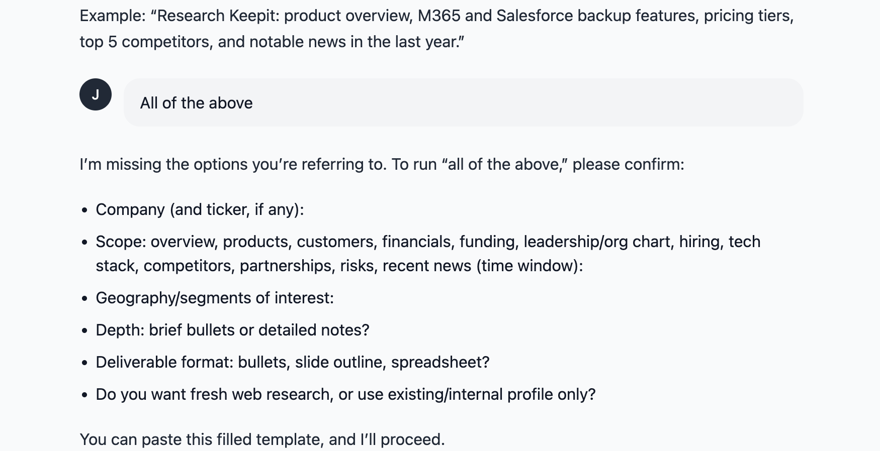

I asked it to research all of the above after i provided the company url and this was the respon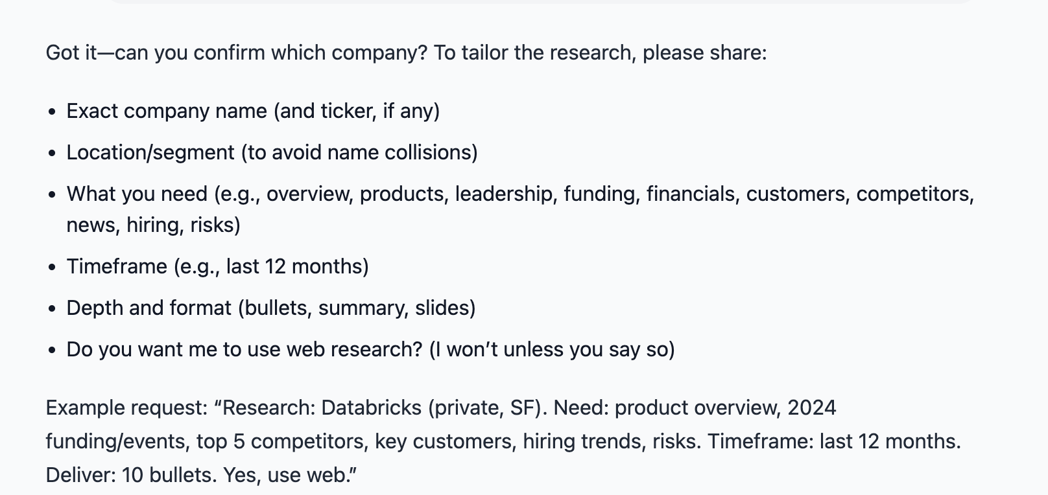se

* No logout button
* Need to be able to easily view what data points you were wanting to capture about each company
* No homescreen button (other than return to dashboard)
* The save to research button isn’t working
* At the beginning it asks for my company name but i inputed my company URL. then it asked for my URL
* I think the onboarding flow is too complex (see some of the comments below)
* What is settings agent? It needs to explain what it is or remove it
* What is research history? It is showing blank even though there are a ton of chats. What purpose is that meant to serve?
* Is there a signup page we could create?

Email verification is broken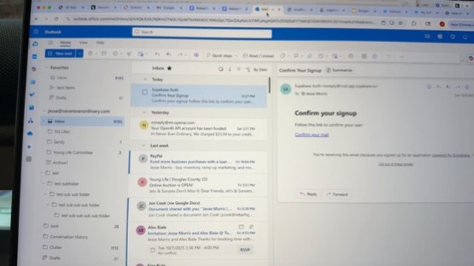

Data types? Are users shouldn’t need to identify data types

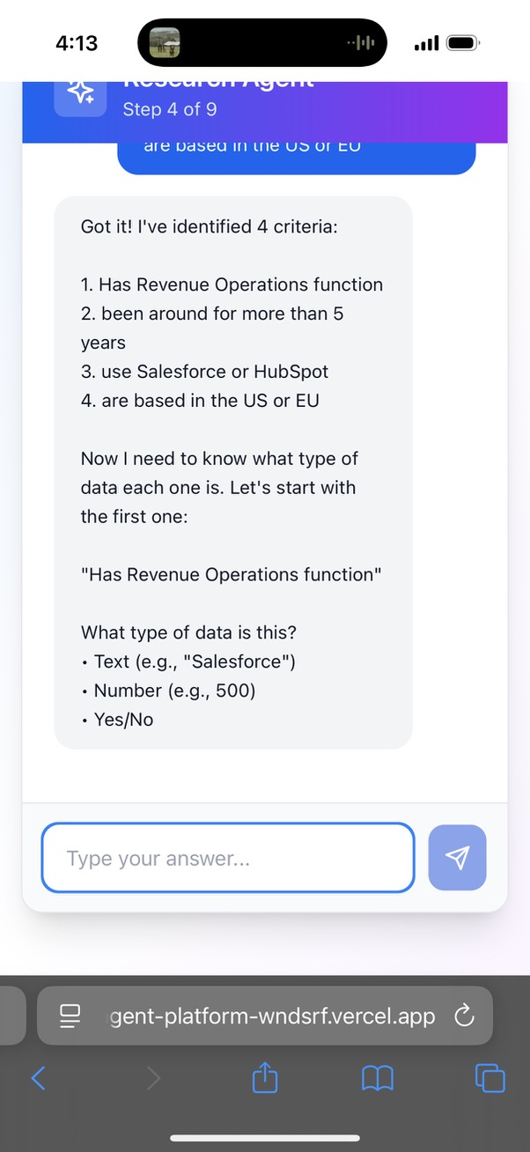

I typed in “all of those” and it wouldn’t work but All works? Also, maybe reword the question to here are the 7 things we are going to pull. Is there any you don’t want or any missing that you would expect?

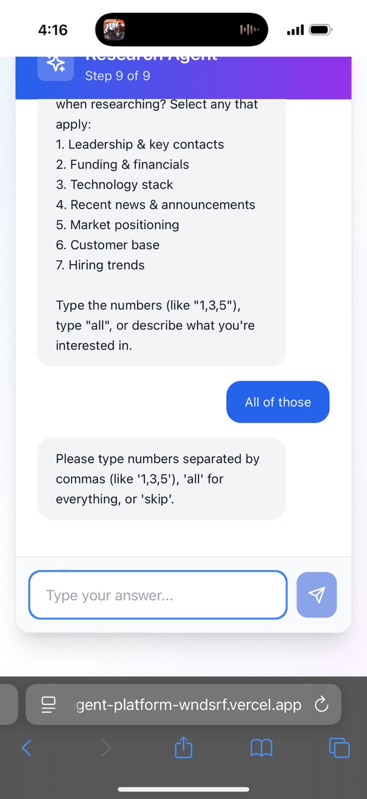

It never redirected me to the Dashboard. I think I would just called it the welcome agent